DATABASE MANAGEMENT — SQL&PL/SQL

SESSION – 1

1.Install MySQL Workbench on your computer, connect to the local MySQL server, and take a screenshot of the default databases shown in the Schemas panel.
ANS:
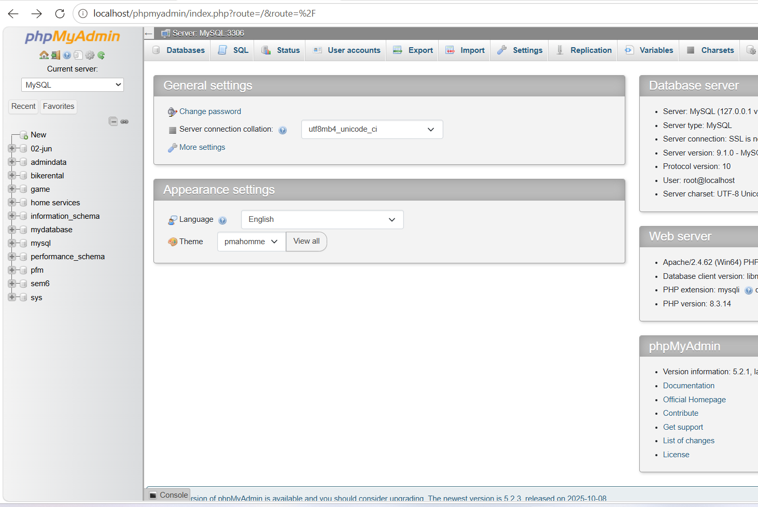

2.Create a new database called InstaClone in MySQL Workbench, then create a table named Users with columns: user_id (INT, primary key), username (VARCHAR), email (VARCHAR), and followers_count (INT).
ANS:
CREATE TABLE Users(
user_id INT PRIMARY KEY,
username VARCHAR(100),
email VARCHAR(100),
followers_count INT );

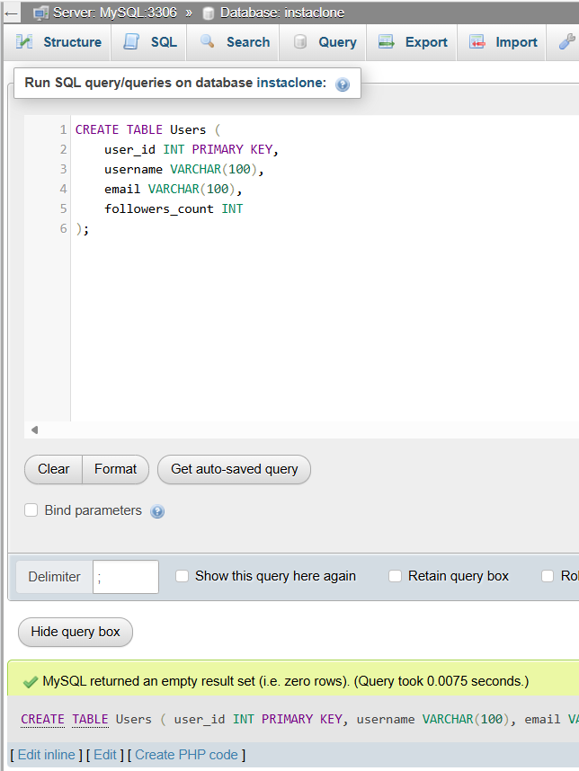

3.Insert 3 sample users into the Users table you created, using realistic Instagram-style usernames and follower counts.
ANS:
USE InstaClone;

INSERT INTO Users (user_id, username, email, followers_count)
VALUES
(1, ‘dhruv_mistry’, 'dhruv@gmail.com', 1250),
(2, 'travel_with_raj', 'raj@gmail.com', 3420),
(3, 'creative_isha', 'isha@gmail.com', 875);

SELECT * FROM Users;

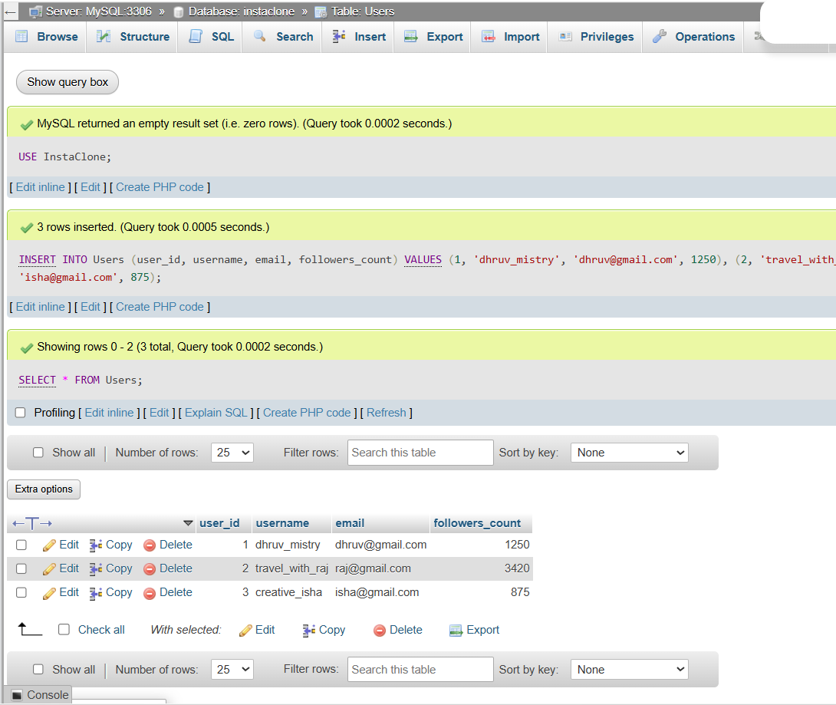

4.Create another table in the InstaClone database called Posts with columns: post_id (INT, primary key), user_id (INT), caption (VARCHAR), and post_date (DATE). Add a foreign key from Posts.user_id to Users.user_id to establish a relationship.
ANS:
USE InstaClone;

CREATE TABLE Posts (
post_id INT PRIMARY KEY,
user_id INT,
caption VARCHAR(255),
post_date DATE,
FOREIGN KEY (user_id) REFERENCES Users(user_id)
);
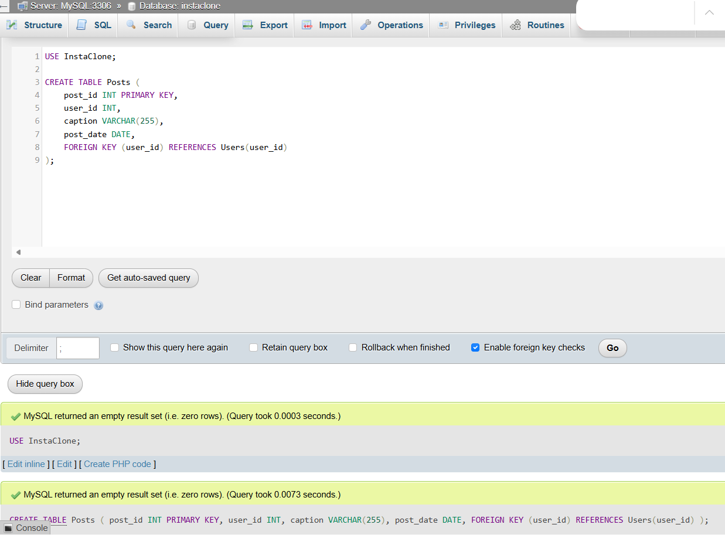

5.Write a short comparison (3-4 lines each) of MySQL, PostgreSQL, Oracle, and SQLite, focusing on where each one is commonly used (for example: web apps, mobile apps, enterprise systems, etc.).
ANS:
1. MySQL
MySQL is widely used for web applications and websites.
It is popular with PHP, WordPress, and other web development technologies.
It is suitable for small to large applications and is easy to use.
2. PostgreSQL
PostgreSQL is an advanced open-source relational database.
It is commonly used for web applications, data analysis, and applications requiring complex queries.
It is known for reliability, flexibility, and strong SQL support.
3. Oracle
Oracle Database is mainly used in large enterprise systems.
Banks, governments, and large organizations use it for handling huge amounts of critical data.
It provides strong security, scalability, and transaction management.
4. SQLite
SQLite is a lightweight database that does not require a separate server.
It is commonly used in mobile apps, desktop applications, and embedded systems.
It is especially useful when a simple, local database is required.

